REPORT ON LOW FREQUENCY MODE ESTIMATION USING

AMBIENT DATA

On August 10, 1996-The Western Electricity Coordinating Council (WECC) blackout originated from negative damping arose from sin6 nonlinearity . WECC is geographically the largest and most diverse of the eight Regional Entities with delegated authority from the [**North American Electric Reliability Corporation (NERC)**](https://en.wikipedia.org/wiki/North_American_Electric_Reliability_Corporation) .The WECC blackout happened because the initial states fell in the unstable region. The oscillations kept on increasing which made the whole power system unstable.

[Earlier the frequency was 0.266 Hz with near zero damping ( 20-35 sec).But there was improvement when AGC(Automatic Generation control was used . The oscillation decrease to 0.242 Hz and damping change to "-2.66%."](https://www.google.com/search?sxsrf=ALiCzsZ5-C2aQTPmv10XxVfBYaLb2jmJ2Q:1651164361463&q=Earlier+the+frequency+was+0.266+Hz+with+near+zero+damping+(+20-35+sec).But+there+was+improvement+when+AGC(Automatic+Generation+control+was+used+.+The+oscillation+decrease+to+0.242+Hz+and+damping+change+to+%22-2.66%25.%22&sa=X&ved=2ahUKEwil-evJmrf3AhXjldgFHQPTDz0Q2LwHegQIARAC)

[At 15:42:37 the Allston - Keeler 500 kV line sag close to a tree and flashed over. The line was tripped leading to unsuccessful single pole reclosure. Due to the Keeler breaker configuration, the Keeler-Pearl 500 kV line also tripped.](https://www.google.com/search?sxsrf=ALiCzsb0t1M_ZwfeItNyz_BAVhz3dRmT0Q:1651164422348&q=At+15:42:37+the+Allston+-+Keeler+500+kV+line+sag+close+to+a+tree+and+flashed+over.+The+line+was+tripped+leading+to+unsuccessful+single+pole+reclosure.+Due+to+the+Keeler+breaker+configuration,+the+Keeler-Pearl+500+kV+line+also+tripped.&spell=1&sa=X&ved=2ahUKEwiBiPDmmrf3AhXc7nMBHR-WAbMQBSgAegQIARAy)

Prior to the outage, the Allston - keeler line was carrying power of 1300 MW and the power was re-routed from Cascade Mountains ( Vantage- Hanford,500 kV).Finally, the system breakup into four island with loss of 30,390 MW of load . Around 7.49 million customers were affected by this. We know that power system is interconnected system .

The power system consists of large Synchronous Generators , transformers. These equipments are very expensive hence to protect the system from such high loss protective equipments have to be there .

The word blackout means a power outage. This means that there is no supply of electricity to a part of a power system. It is a total crash of the power grid due to an imbalance between power generation and power consumption.

The above black-out explains that importance on-line estimations of these low frequency modes, for taking preventive control action. These estimated modes can also be used for designing and tuning of power system stabilizes.

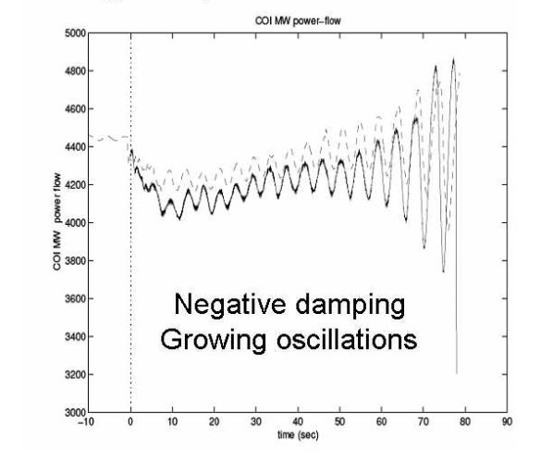

Classification of various methods for low frequency mode estimation:

1.**Off-line approach:**

**Small signal stability using eigenvalue analysis**

**∆ ̇x=A∆x+B∆u**

**2. On-line methods based on Synchrophasor Measurements :**

1.**Using Ambient System Data**

a) Whitening filter:

An electrical filter which converts a given signal to white noise. Also known as pre whitening filter.

b) Least Squares:

Least-squares method is proposed for online power system frequency estimation. The algorithm is based on a formula which holds for every three consecutive samples. Several of these formulae are written for some consecutive triples of samples and the least-squares method is applied to estimate the frequency. A revised version of the approach with less computation burden at the cost of little decline in estimation accuracy is presented

c) Recursive Least Squares:

Recursive-least-squares (RLS) algorithm is applied to the frequency estimation of the instantaneous power system. The three-phase voltage signal is transformed to a complex form which is easy to be handled by the proposed approach. When compared with other algorithms, the RLS algorithm is more suitable for online frequency estimation due to its rapid convergence rate.

d) Robust Re-cursive Least Squares:

The algorithm shows accurate frequency estimation performance and wide range of robustness in the presence of severe sensor measurement noises. since it requires small amount of computations compared to the existing estimators, it is attractive for real-time implementation.

e) Empirical mode decomposition (EMD) along with Hilbert Transform:

Empirical mode decomposition is basically a shifting process in which different mode of oscillation are sieved out of original signal. The modes thus extracted are monocomponent signals comprising of a narrow band of frequencies

2. **Using ring down or probing data**

**a) Discrete Fourier Transform:**

The discrete Fourier transform (DFT) converts a finite sequence of equally-spaced [samples](https://en.wikipedia.org/wiki/Sampling_(signal_processing)) of a [function](https://en.wikipedia.org/wiki/Function_(mathematics)) into a same-length sequence of equally-spaced samples of the [discrete-time Fourier transform](https://en.wikipedia.org/wiki/Discrete-time_Fourier_transform) (DTFT), which is a [complex-valued](https://en.wikipedia.org/wiki/Complex_number) function of frequency.

**b) Prony Method:**

Prony analysis can be used to determine the system modes from a ringdown signal. If a linear state space model can describe the system, the homogeneous responses of the system to a disturbance are a sum of exponentially damped sinusoidal signals.

**c)Estimation of signal parameters via rotational invariance techniques (ESPRIT):**

It is a technique to determine parameters of a mixture of [sinusoids](https://en.wikipedia.org/wiki/Sine_wave) in a background noise. This technique is first proposed for frequency estimation, however, with the introduction of [phased-array](https://en.wikipedia.org/wiki/Phased-array) systems in daily use technology, it is also used for [Angle of arrival](https://en.wikipedia.org/wiki/Angle_of_arrival) estimations as well.

White noise Power system (sampled data)

Whitening Filter

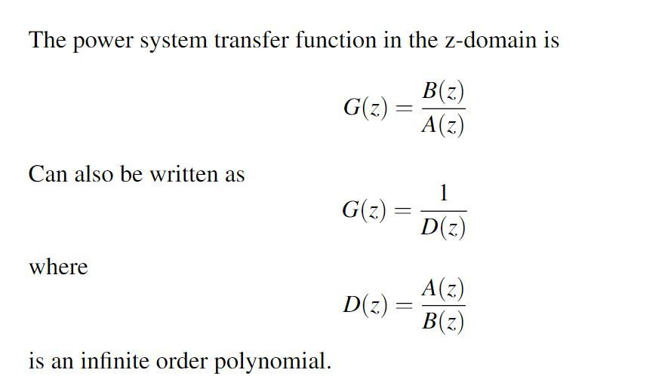

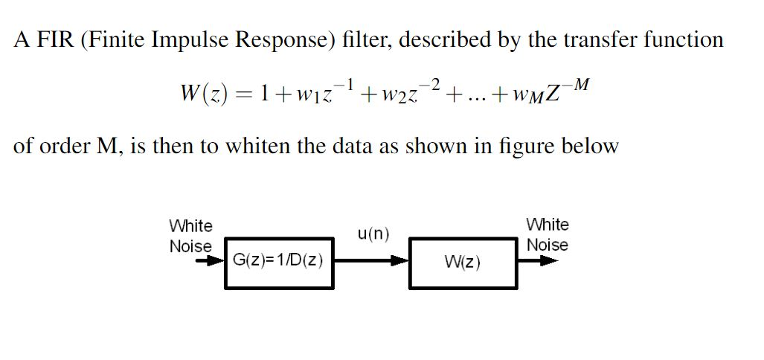

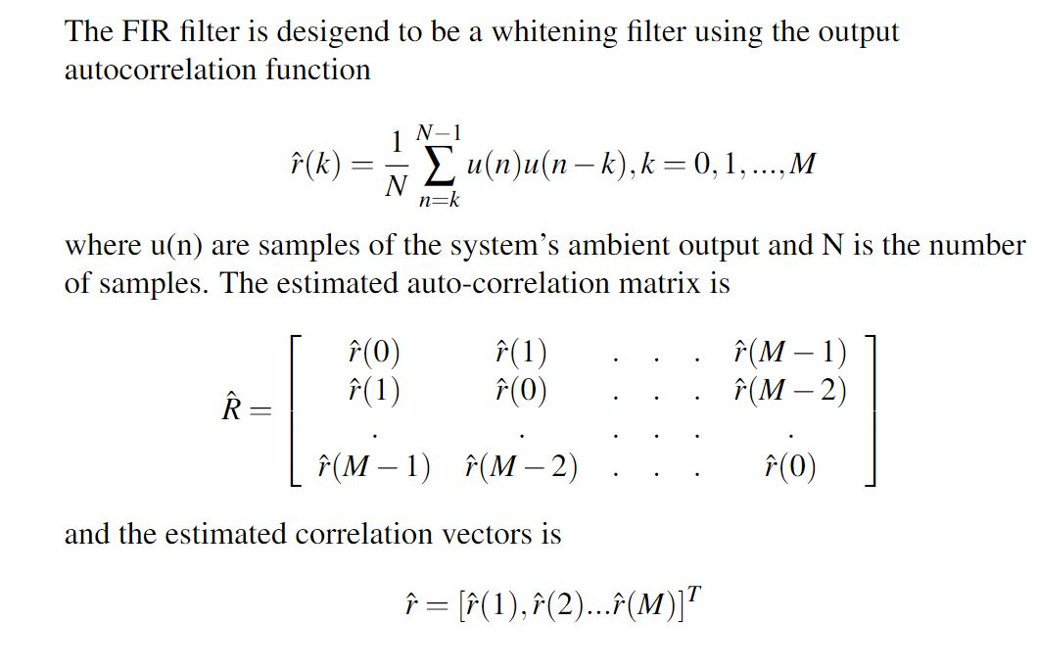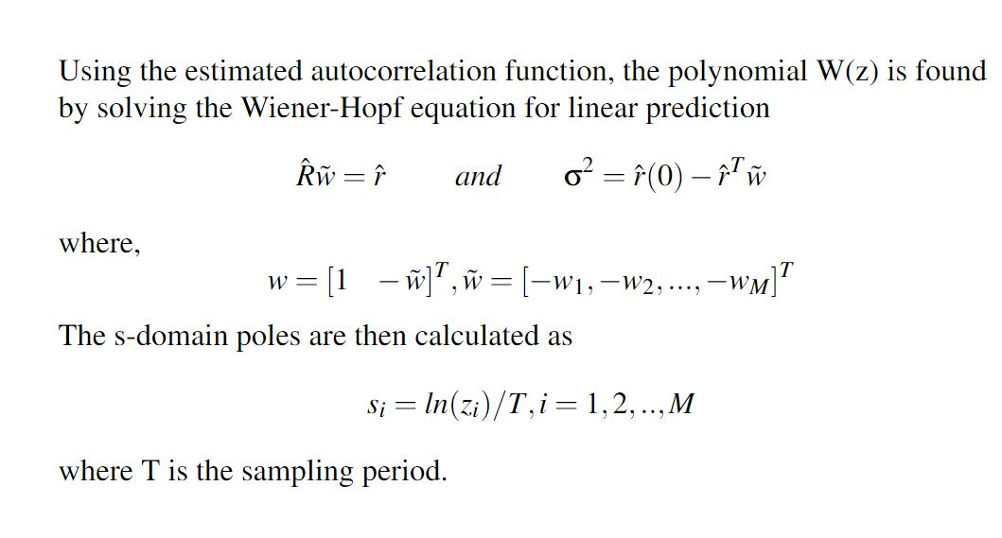

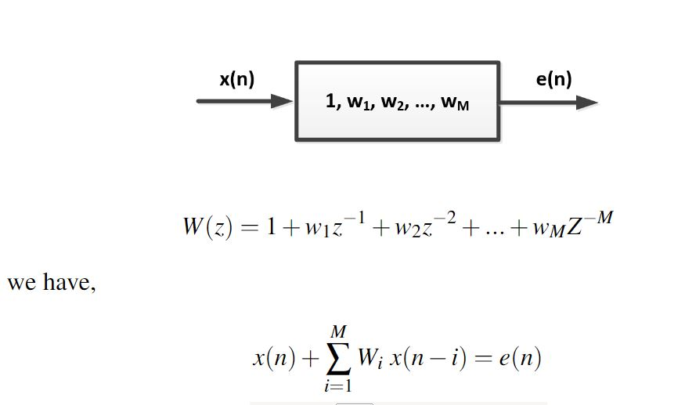

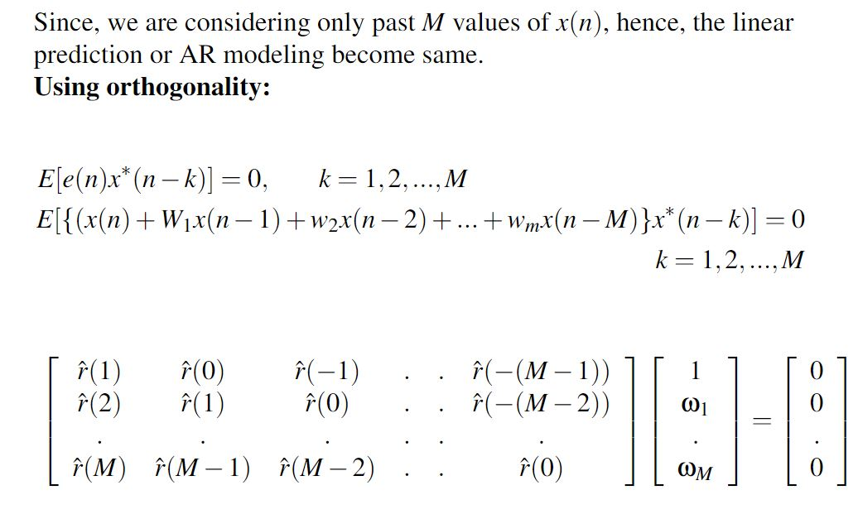

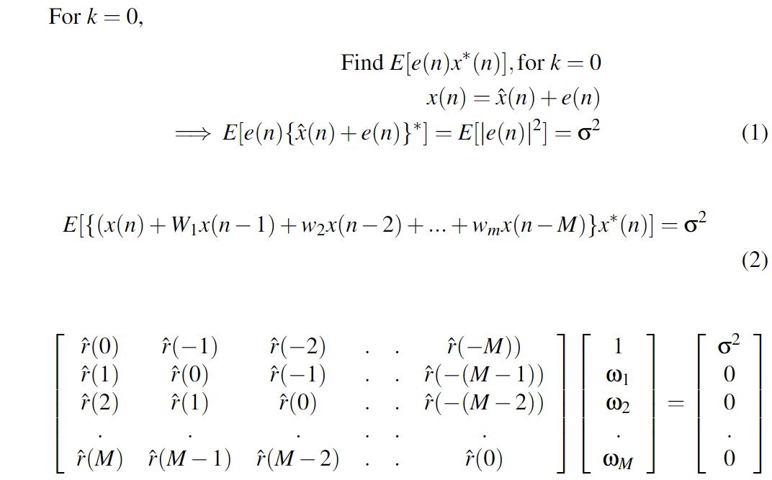

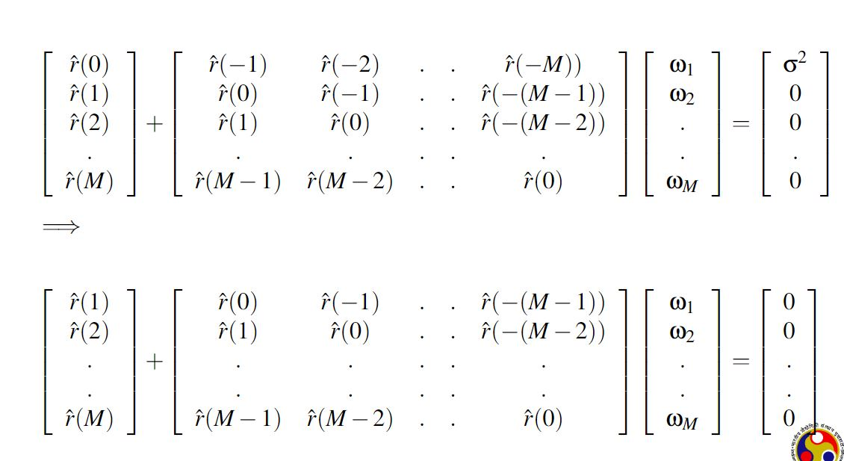

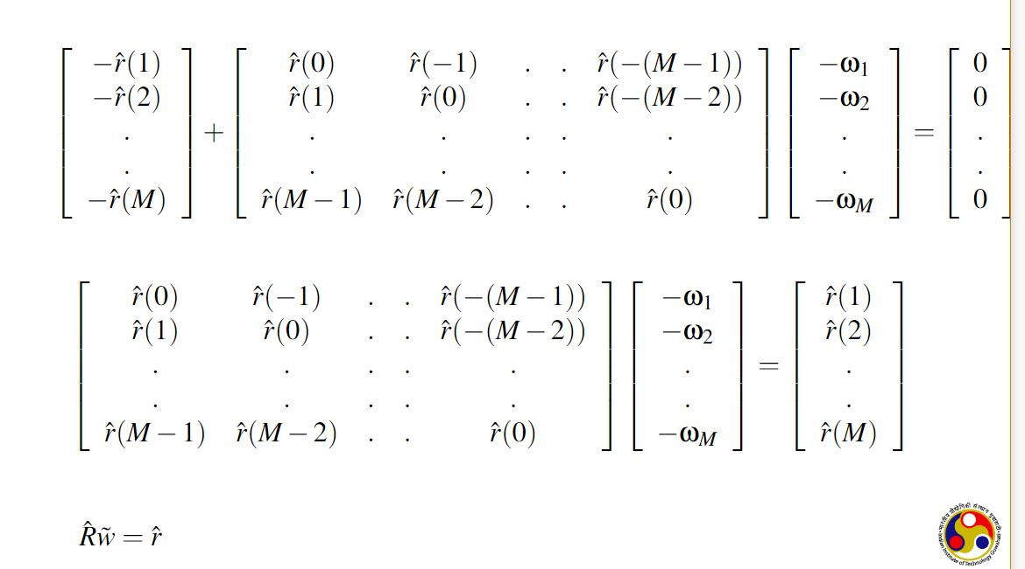

Code:

We have implemented different values of k to assign different order FIR filter for whitening filter and got the location of poles so that we can determine the stability of the Power system for different designing configuration.

N=length(VarName1);

M=k;

for i=1:M+1

r(i)=0;

for j = i:N

r(i)= r(i) + VarName1(j)*VarName1(j-i+1);

end

r(i)=r(i)/N;

end

rc=zeros(M,1);

% estimation of correlation verctor

for i=2:M+1

rc(i-1,1)=r(i);

end

% estimation of Auto-correlation matrix

R=zeros(M,M);

for i=1:M

for j=1:M

if i==j

R(i,j)=r(1);

else

if i>j

R(i,j)=r(i-j+1);

end

if i<j

R(i,j)=r(j-i+1);

end

end

end

end

w = inv(R)*rc;

den=[1 -w'];

zz=zeros(1,2000);

num=[1 zz];

H=tf(num,den,1/3);

P=pole(H);

P_n=3*log(P);

nun=[1];

den=[P_n]';

k=1;

S=zpk(nun,den,k);

r=pzplot(S);

system = tf(nun,den);

Plots of poles:

For k =2

For k=3

For k=2000

Result:

For M=3

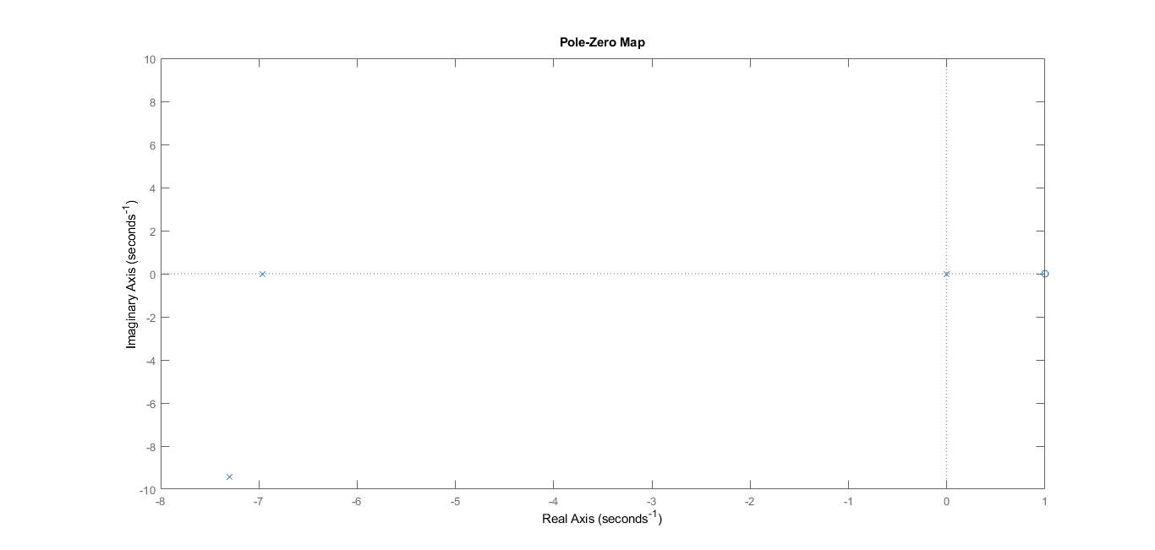

* For M = 2

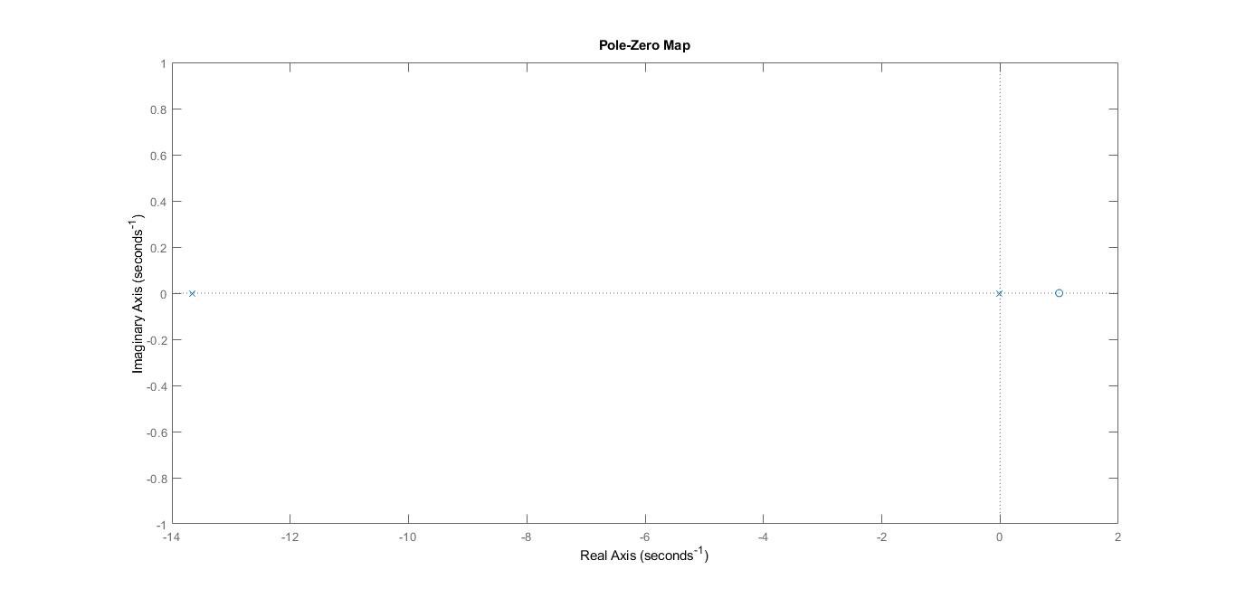

* For Ambient data

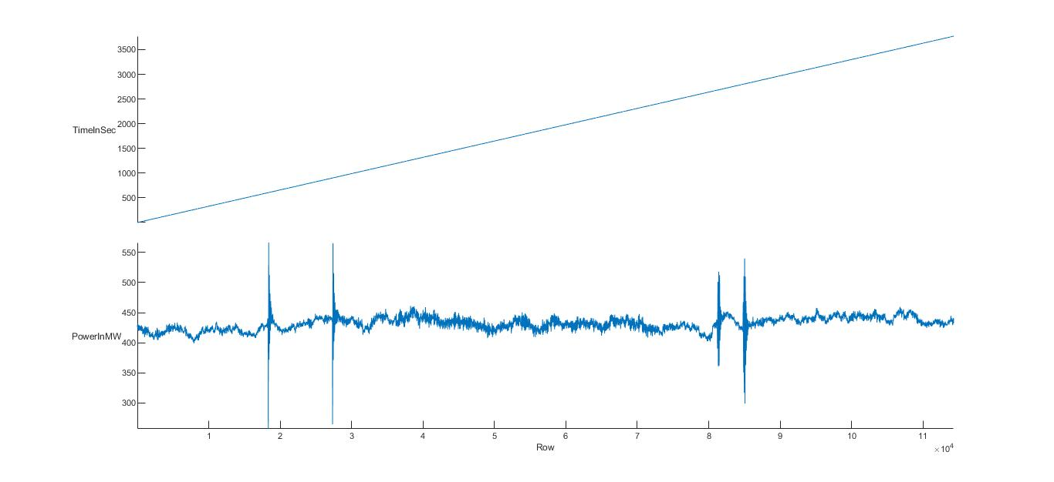

* For M=2000

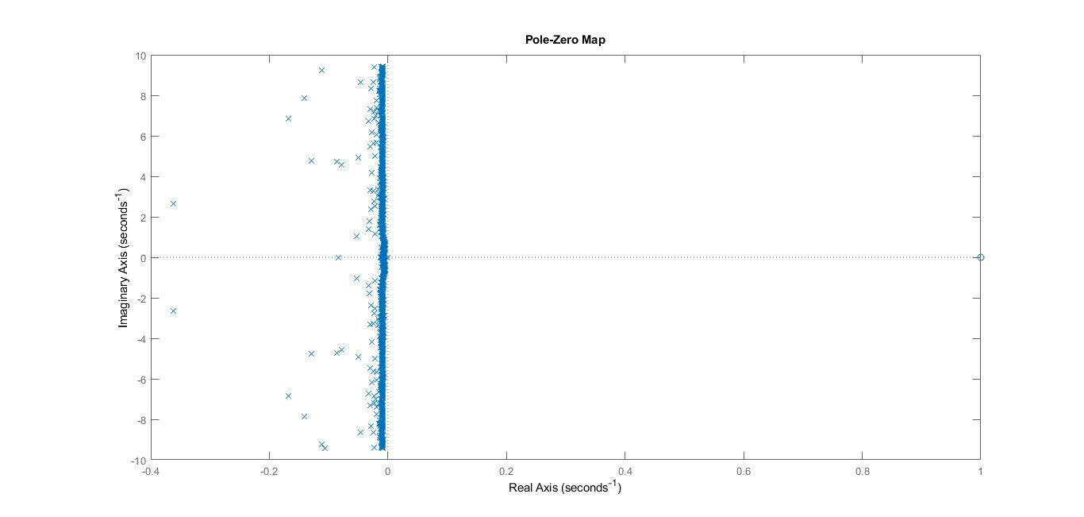

Conclusion:

* So we can clearly see from the results that in all simulation diagrams. The poles are left half of the imaginary plane.
* So we can conclude from the analysis that for the given data the system is seeming to be stable for all FIR filter Configurations.